Set 6
Program 1-Grouped Bar Chart
product <- data.frame(
Product = c("Product A", "Product B", "Product C"),
January = c(2000, 1500, 1200),
February = c(2200, 1800, 1400),
March = c(2400, 1600, 1100)
)
sales <- t(as.matrix(product[,2:4]))
barplot(
sales,
beside = TRUE,
col = c("red","blue","green"),
names.arg = product$Product,
main = "Grouped Bar Chart of Monthly Product Sales",
xlab = "Products",
ylab = "Sales"
)
legend(
"topleft",
legend = c("January","February","March"),
fill = c("red","blue","green")
)

Output:

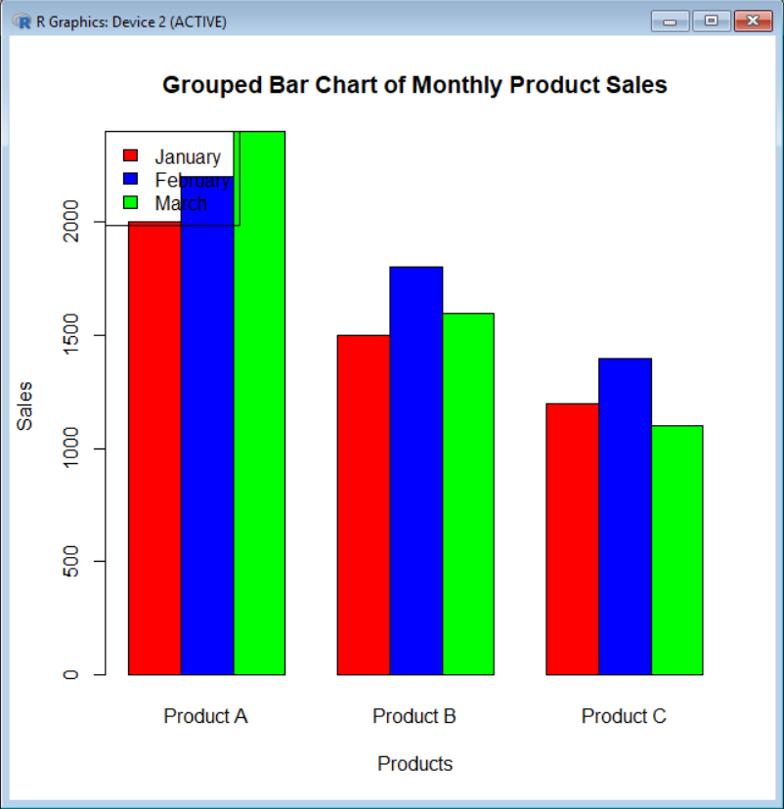

Program 2-Stacked Bar Chart
product <- data.frame(
Product = c("Product A", "Product B", "Product C"),
January = c(2000, 1500, 1200),
February = c(2200, 1800, 1400),
March = c(2400, 1600, 1100)
)
sales <- t(as.matrix(product[,2:4]))
barplot(
sales,
beside = FALSE,
col = c("red","blue","green"),
names.arg = product$Product,
main = "Stacked Bar Chart of Product Sales",
xlab = "Products",
ylab = "Sales"
)
legend(
"topleft",
legend = c("January","February","March"),
fill = c("red","blue","green")
)

Output:
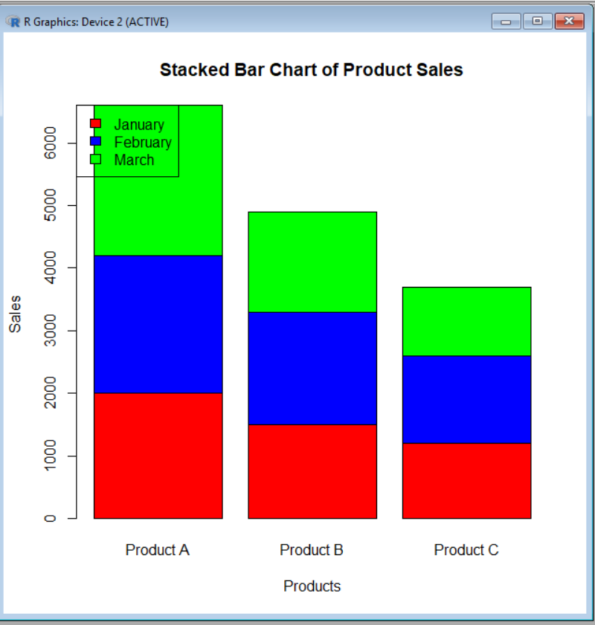
Program 3-Display Data Table
product <- data.frame(
Product_ID = c(1,2,3),
Product_Name = c("Product A","Product B","Product C"),
January = c(2000,1500,1200),
February = c(2200,1800,1400),
March = c(2400,1600,1100)
)
print("Monthly Product Sales Table")
print(product)

Output:
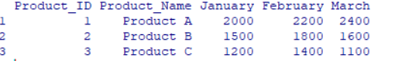

Program 4-Total Sales Calculation
product <- data.frame(
Product_Name = c("Product A","Product B","Product C"),
January = c(2000,1500,1200),
February = c(2200,1800,1400),
March = c(2400,1600,1100)
)
product$Total_Sales <- rowSums(product[,2:4])
print(product)
cat("\nHighest Selling Product:",
product$Product_Name[which.max(product$Total_Sales)])

Output:
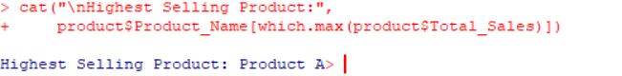

Set 7
Program 1 - Bar Chart (Customer Ages)
customer <- data.frame(
Customer_ID = c(1,2,3),
Age = c(28,35,42),
Gender = c("Female","Male","Female"),
Income = c(50000,60000,75000)
)
barplot(
customer$Age,
names.arg = customer$Customer_ID,
col = "skyblue",
main = "Customer Age Distribution",
xlab = "Customer ID",
ylab = "Age"
)

Output:
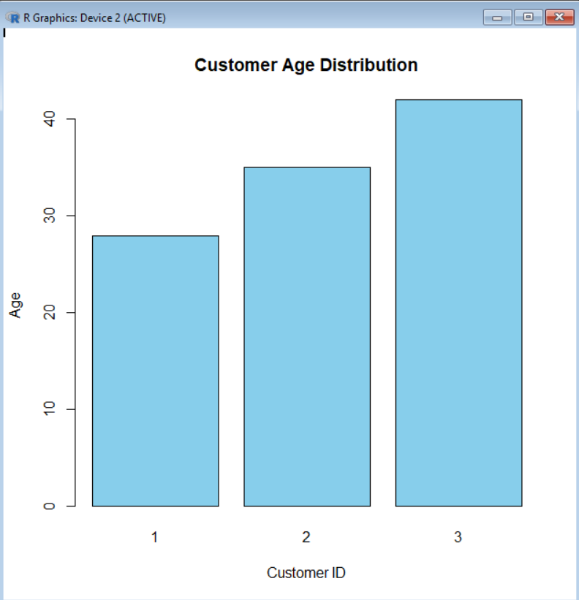

Program 2 - Pie Chart (Gender Distribution)
customer <- data.frame(
Customer_ID = c(1,2,3),
Age = c(28,35,42),
Gender = c("Female","Male","Female"),
Income = c(50000,60000,75000)
)
gender_count <- table(customer$Gender)
pie(
gender_count,
col = c("pink","lightblue"),
main = "Customer Gender Distribution"
)

Output:
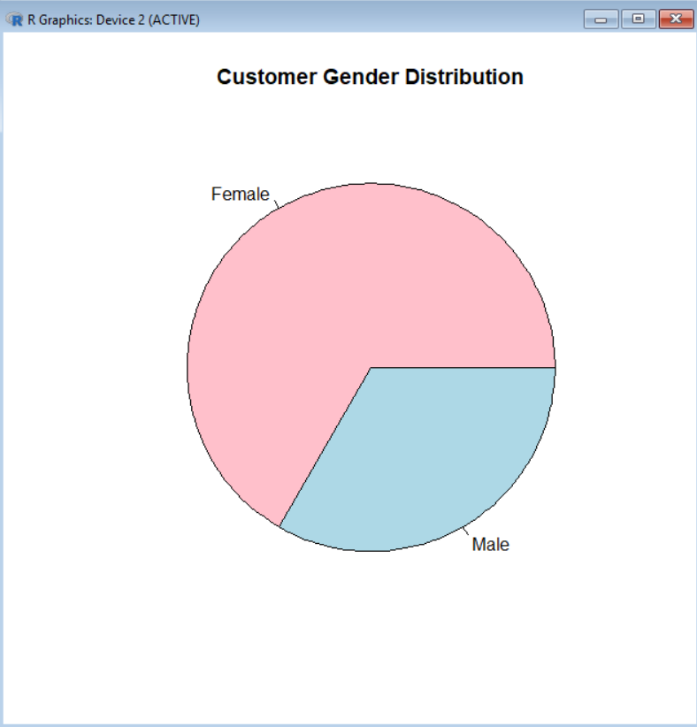

Program 3 - Display Data Table
customer <- data.frame(
Customer_ID = c(1,2,3),
Age = c(28,35,42),
Gender = c("Female","Male","Female"),
Income = c(50000,60000,75000)
)

print("Customer Demographics Table")
print(customer)

Output:
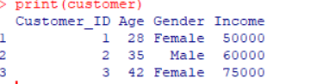

Program 4 – Summary of Customer Data
customer <- data.frame(
Customer_ID = c(1,2,3),
Age = c(28,35,42),
Gender = c("Female","Male","Female"),
Income = c(50000,60000,75000)
)
cat("Average Age:", mean(customer$Age), "\n")
cat("Average Income:", mean(customer$Income), "\n")
print(table(customer$Gender))
Output:
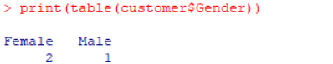
Set 8
Program 1 - Line Chart (Performance Trend)
employee <- data.frame(
Employee_ID = c(1,2,3),
Department = c("Sales","HR","Marketing"),
Years_Service = c(5,3,7),
Performance_Score = c(85,92,78)
)
plot(
employee$Years_Service,
employee$Performance_Score,
type = "o",
col = "blue",
pch = 16,
main = "Employee Performance Trend",
xlab = "Years of Service",
ylab = "Performance Score"
)
Output:
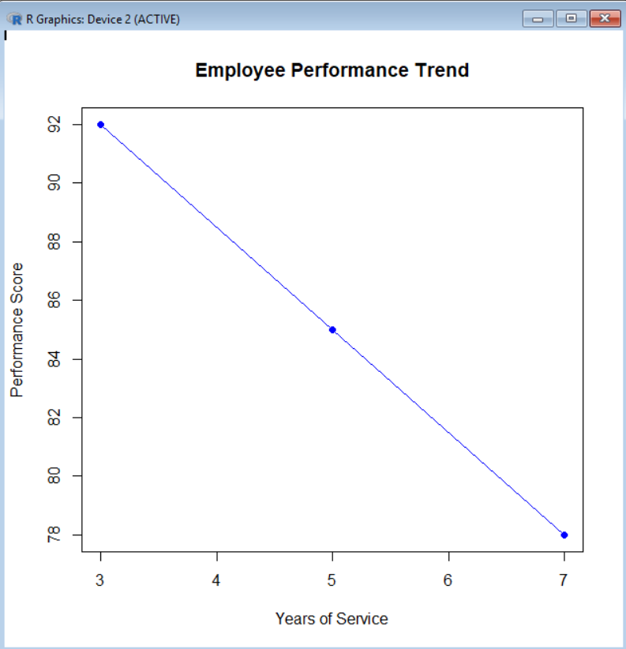

Program 2 - Bar Chart (Employees Across Departments
employee <- data.frame(
Employee_ID = c(1,2,3),
Department = c("Sales","HR","Marketing"),
Years_Service = c(5,3,7),
Performance_Score = c(85,92,78)
)
dept_count <- table(employee$Department)
barplot(
dept_count,
col = c("red","green","blue"),
main = "Employees by Department",
xlab = "Department",
ylab = "Number of Employees"
)
Output:
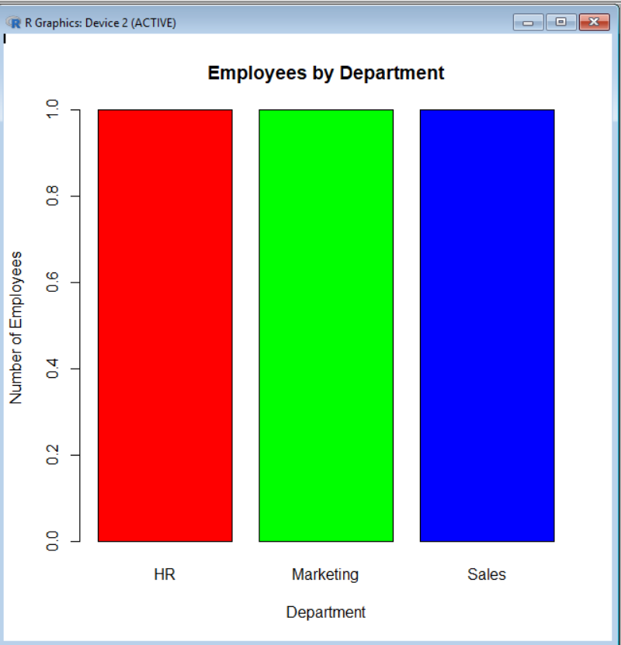

Program 3 - Display Data Table
employee <- data.frame(
Employee_ID = c(1,2,3),
Department = c("Sales","HR","Marketing"),
Years_Service = c(5,3,7),
Performance_Score = c(85,92,78)
)
print("Employee Performance Table")
print(employee)
Output:
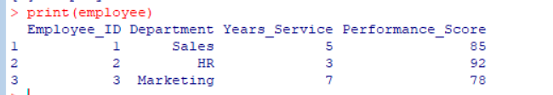

Program 4 -Employee Performance Summary
employee <- data.frame(
Employee_ID = c(1,2,3),
Department = c("Sales","HR","Marketing"),
Years_Service = c(5,3,7),
Performance_Score = c(85,92,78)
)
cat("Average Performance Score:",
mean(employee$Performance_Score), "\n")

cat("Average Years of Service:",
mean(employee$Years_Service), "\n")
cat("Best Performing Employee ID:",
employee$Employee_ID[which.max(employee$Performance_Score)], "\n")

Output:
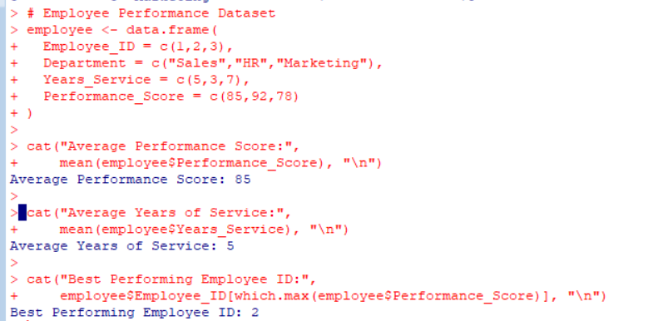

Srt 9
Program 1-Histogram and Box Plot
data <- data.frame(
Student_ID = c("L01","L02","L03","L04","L05","L06"),
Gender = c("Male","Female","Male","Female","Male","Female"),
Age = c(20,22,19,21,23,20),
Course = c("R","R","SQL","R","R","SQL"),
Study_Time = c(3.5,4.2,2.0,5.0,2.5,4.0),
Videos_Watched = c(12,15,8,18,9,14),
Quiz_Score = c(78,85,65,92,70,88),
Login_Date = c("2025-01-05","2025-01-05","2025-02-08",
"2025-02-08","2025-03-12","2025-03-12")
)
hist(data$Quiz_Score,
col="skyblue",
main="Histogram of Quiz Scores",
xlab="Quiz Score")
boxplot(Quiz_Score ~ Course,
data=data,
col=c("orange","lightgreen"),
main="Quiz Score by Course",
xlab="Course",
ylab="Quiz Score")

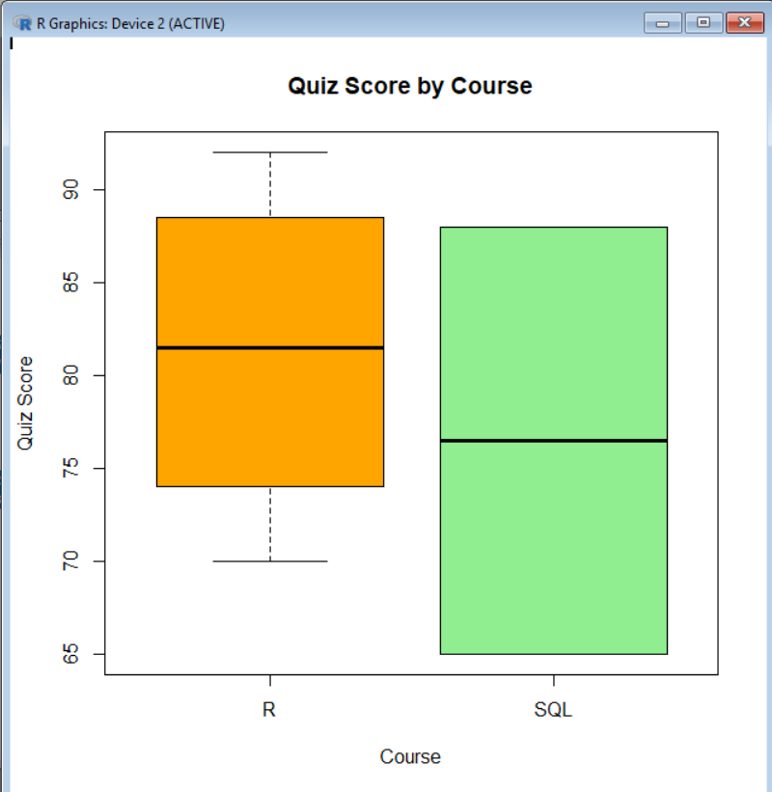
Output:

Program 2-Scatter Plot with Bubble Size
data <- data.frame(
Student_ID = c("L01","L02","L03","L04","L05","L06"),
Gender = c("Male","Female","Male","Female","Male","Female"),
Age = c(20,22,19,21,23,20),
Course = c("R","R","SQL","R","R","SQL"),
Study_Time = c(3.5,4.2,2.0,5.0,2.5,4.0),
Videos_Watched = c(12,15,8,18,9,14),
Quiz_Score = c(78,85,65,92,70,88)
)
plot(data$Study_Time,
data$Quiz_Score,
cex=data$Videos_Watched/5,
pch=19,
col=rgb(0,0,1,0.5),
main="Study Time vs Quiz Score",
xlab="Study Time (Hours)",
ylab="Quiz Score")
Output:
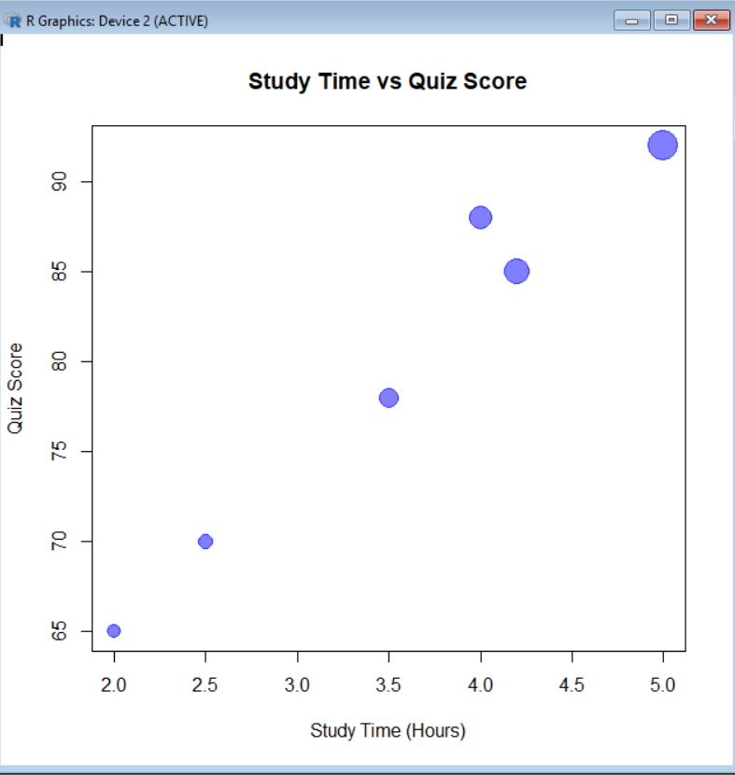

Program 3-Monthly Average Quiz Score
data <- data.frame(
Student_ID = c("L01","L02","L03","L04","L05","L06"),
Quiz_Score = c(78,85,65,92,70,88),
Login_Date = c("2025-01-05","2025-01-05","2025-02-08",
"2025-02-08","2025-03-12","2025-03-12")
)
data$Login_Date <- as.Date(data$Login_Date)
data$Month <- format(data$Login_Date,"%B")
avg_score <- aggregate(Quiz_Score ~ Month, data, mean)
print(avg_score)
plot(avg_score$Quiz_Score,
type="o",
col="blue",
xaxt="n",
main="Average Monthly Quiz Score",
xlab="Month",
ylab="Average Quiz Score")

axis(1, at=1:nrow(avg_score), labels=avg_score$Month)
Output:
